**MAWLANA BHASHANI SCIENCE AND TECHNOLOGY UNIVERSITY**

**SANTOSH, TANGAIL-1902**



**DEPARTMENT OF INFORMATION AND COMMUNICATION TECHNOLOGY**

**Lab Report No: 03**

**Course Title:** Communication Engineering Lab

**Course Code:** ICT-2206

**Lab Report on:** Frequency Modulation and Demodulation

|  |  |
| --- | --- |
| **Submitted By** | **Submitted To** |
| **Name: Kuldip Saha Mugdha**  **ID: IT-22018**  **2nd Year, 2nd Semester**  **Session: 2021-2022**  **Dept. of ICT, MBSTU** | **Dr.Monir Morshed**  **Professor**  **Department of Information and Communication Technology**  **Mawlana Bhashani Science and Technology University** |

**Date of Performance: 10/03/2025 Date of Submission: 12/03/2025**

**Introduction:**

Frequency Modulation (FM) is a technique where the frequency of a carrier wave is varied according to the amplitude of the message signal. FM is widely used in radio broadcasting, two-way radio communication, and TV audio transmission due to its high noise resistance and improved sound quality compared to Amplitude Modulation (AM).

**Equipments:**

1.Signal Oscillator

2.MATLAB

3.Oscilloscope

4.Function generator

5.Connecting wires

6.Power supply

**Theory:**

In Frequency Modulation (FM), the frequency of the carrier wave changes in proportion to the instantaneous amplitude of the message signal. The FM signal is given by:



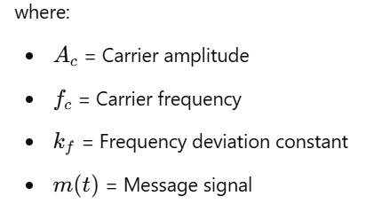

The modulation index (β) determines how much the frequency deviates from its center frequency and is given by:

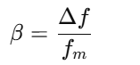

where Δf is the frequency deviation and fm is the message frequency.

Demodulation can be performed using a frequency discriminator or a Phase-Locked Loop (PLL) to recover the original message signal.

**Procedure:**

**Generate Signals**

* Create a message signal (low-frequency sine wave).
* Generate a carrier signal (high-frequency cosine wave).

**2. Apply Frequency Modulation**

* Vary the frequency of the carrier in proportion to the amplitude of the message signal.
* Observe the effect of different modulation indices on the FM signal.

**3. Visualize the Signals**

* Plot the message signal, carrier signal, and FM signal.
* Analyze frequency variation in the FM waveform.

**4. Transmission of FM Signal**

* Simulate the transmission process in MATLAB.

**5. Demodulation Process**

* Use a frequency discriminator or a Phase-Locked Loop (PLL) to extract the message signal.
* Compare the demodulated signal with the original message.

**6. MATLAB Implementation**

* Implement frequency modulation and demodulation using MATLAB.
* Display the output waveforms for analysis.

**MATLAB code:**

**Fs = 10000; Fm = 100; Fc = 1000; Ac = 1; kf = 50; T = 1;**

**t = 0:1/Fs:T-1/Fs;**

**message_signal = cos(2 * pi * Fm * t);**

**modulated_signal = Ac * cos(2 * pi * Fc * t + kf * cumsum(message_signal)/Fs);**

**% Demodulation using differentiation**

**demodulated_signal = [diff(unwrap(angle(hilbert(modulated_signal)))) 0];**

**figure;**

**subplot(3,1,1), plot(t, message_signal), title('Message Signal');**

**subplot(3,1,2), plot(t, modulated_signal), title('Frequency Modulated Signal');**

**subplot(3,1,3), plot(t, demodulated_signal), title('Demodulated Signal');**

**Output:**

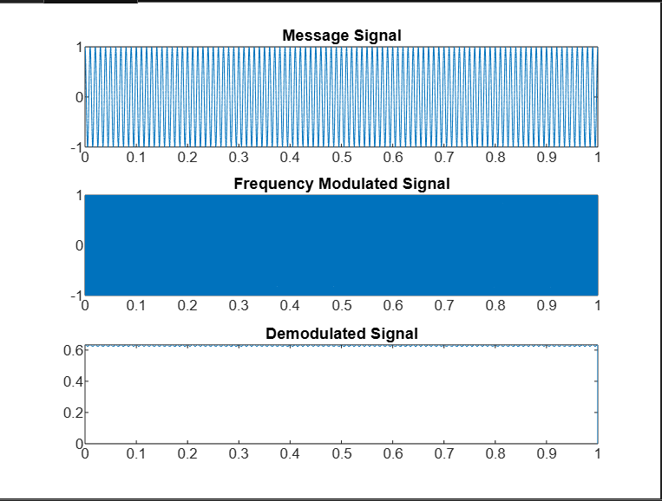

**Discussion:**

This lab successfully demonstrated Frequency Modulation (FM) and its demodulation using MATLAB. The results showed how frequency varies with the message signal and how PLL-based demodulation accurately recovers the original signal. FM is widely used in radio and communication systems due to its robustness against noise and interference.